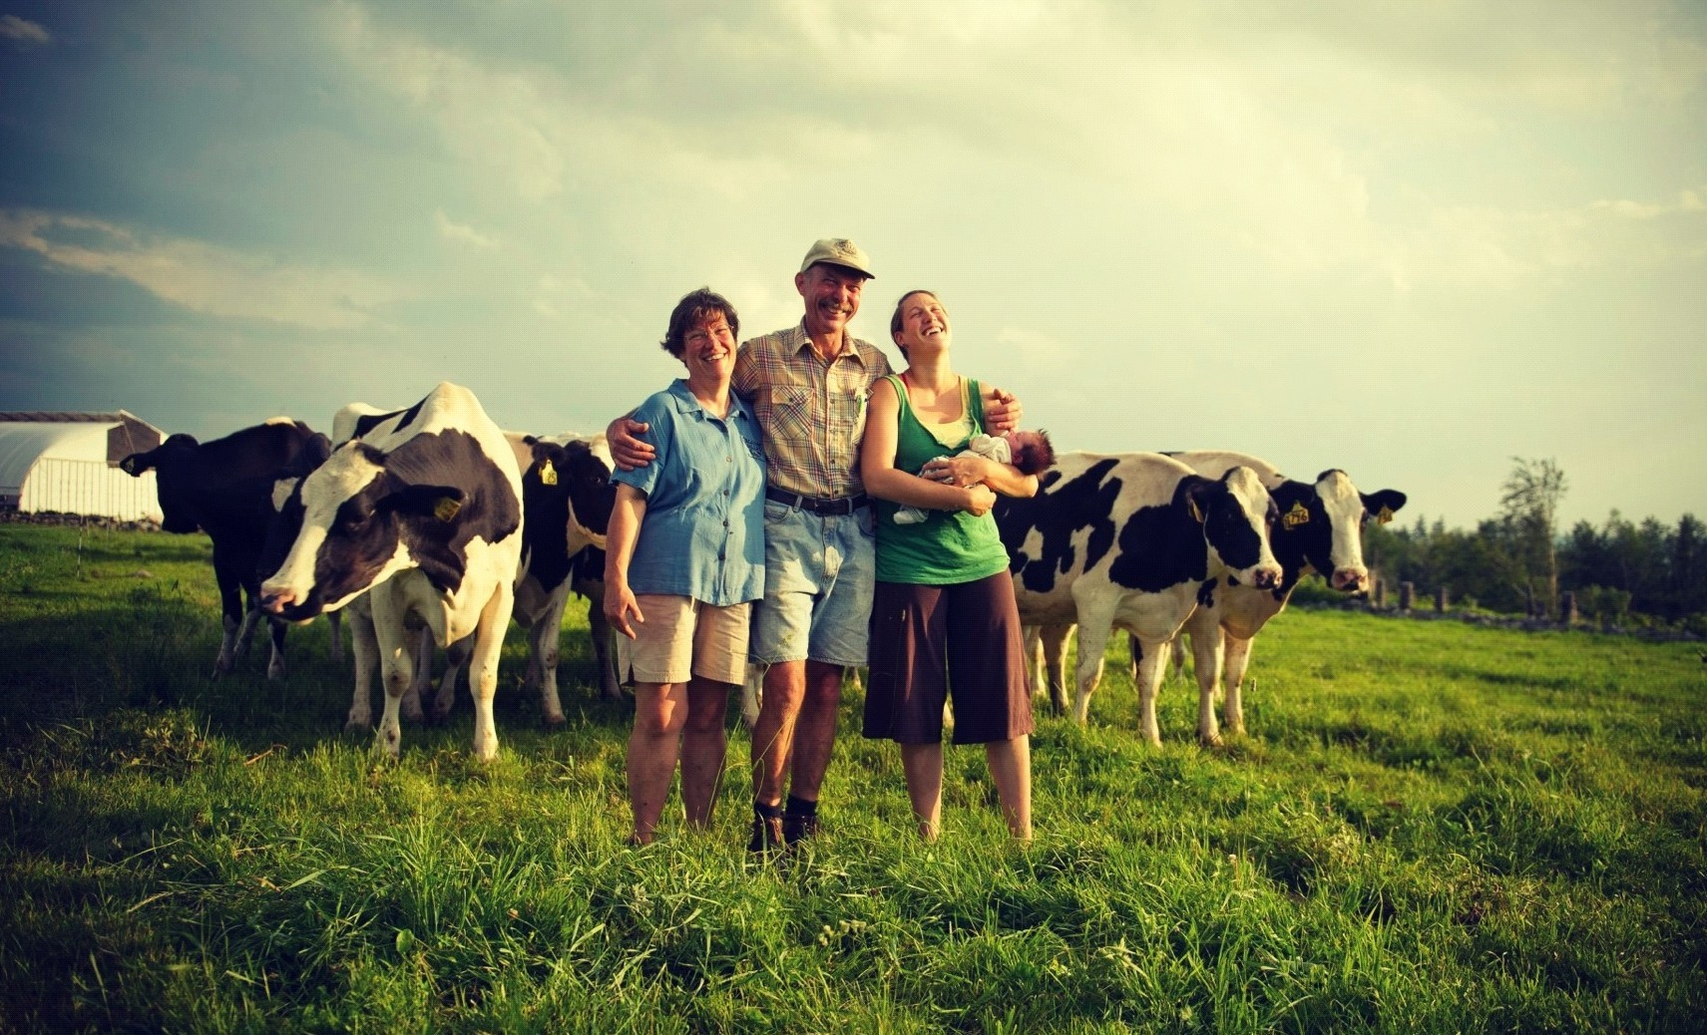

STRATEGIC PLAN FOR NATIONAL COMMITTEE FOR FAMILY FARMING
2017-2022

Content

Resume of the stragety 4
Аnalysis of the situations 5
Analysis of outside environment and analysis of strengthens, weaknesses, opportunities and treats 5
Аnalysis of outiside environment (PEST analysis) 6
Identity 7
Мission 7
Vision 7
Objective 7
Target grups 7
Membership 7
Structure 8
Legal regulation 10
Formulating of specificobjective 17
Spesificobjectives/ Key activities 17
Plan for implementation 18
Sources of financing 25

Resume of the strategy

The strategy for developing of the National Committee for Family Farming 2017-2022 represents basic developed document which predicts the work and the role of the National Committee for Family Farming for the upcoming 5 years long period. The strategy is a result of multi-month process of planning in the period March – June 2017, worked in more phases to few levels with a purpose to include the opinions, interests and needs of the farmers from all the regions, to sublimit the experience from the long- term activists of the organizations which led the process, to project the needs and the future of the new purpose groups to reach unity, harmony and common position around the strategic purposes.
National Committee for Family Farming is a platform which is being formed within the project for analysis of the needs of family farms in Republic of Macedonia which is implemented by CDI- Tetovo with the support of FFRM and RDN from Skopje. The project is supportedbyWorld Rural Forum and FAO and represents basis for implementing of the politics and measures for support on national level in this category of farmers.
Farmers’ need for participation in creating and implementing of politics and measurements for support is huge. This way the farmers themselves can be recognized like a basic doer in transferring the farmers’ voice - which was always part of the creation of new suggestions, analysis and solutions which can lead to better life of the farmers and creation of more competitive farming.
National Committee for Family Farming in its work will be guided by the vision FAMILY FARMS – CARRIERS OF AGRICULTURAL AND RURAL DEVELOPMENT, which will allow stabilization of the population in the villages in the country. With mission FARMERS TOGETHER FOR SUCCESS, the National Committee will work on binding the farmers, local organizations, family agricultural holdings and other shapes with objective REALIZATION OF COMMON INTERESTS FOR DEVELOPMENT, PROFITABILITY AGRICULTURE TO PROVIDE A LIVING LIFE OF THE FARMERS.
The strategy covers all the segments of one structured, clear and precise document which covers the identity, experience, mission, vision, analysis, objectives, activities and expectations for the next 5 years long period. We hope that it will be a great document to begin with, which of coursewe will revise and go back constantly, with a purpose not to forget the meaning of existence and the key purpose of this Committee.
We hope that in the next 5 years long period we will manage to increase the profit in agriculture and to stabilize Macedonian village, through gathering and promoting of the farmers in Republic of Macedonia.

Analysis of the situations

Analysis of outside environment and analysis of strong sides, weak sides, possibilities and treats

Strengthens | Weaknesses
- Member motivation of NCFF  - Wide net of partners and contacts  - Human resources  - Recognition  - Institutional memory of the carrier organizations  - Regional action  - Capacities for creating politics  - Experience / built up position in the community | - Lack of initial capital/ funds  - Part-time project dependence  - Undefined rules and lack of strategy for public relations  - Lack of own premises  - Insufficient level of self- control  - Frequent changes of staff in the organization
Opportunities | Treats
- Changes in legislation and introducing new laws (lobbing and changes)  - Developing of programs and services for self- sustainability  - Activities for support between ethnical relations  - EU -NATO integrations  - Misbalance on the labor market  - Membership in networks  - Availability of EU funds | - Increasing of taxes  - Frequent changes  - Political instability  - Partisan community  Non-transparency / lack of  communication channels  - Decreased inflow of funds  - Poverty/ decreased purchasing power  - Creating a climate of unstable between- ethnical relations  - Non- transparent non- cooperative and uninterested institutions  - Decreased interests from foreign donors

Analysis of outside environment (PEST analysis)

Political | Economical
- Frequent early and parliamentary elections  - Non- cooperativity of the institutions of the central government  - Sensitive between- cultural relations  - Political informal agreements/ solutions for questions which ethnic communities are concerned with  - Implementation of OFA on local level  - Unstable political surrounding/ home  - EU/ NATO integrations/ candidate status | - Frequent changes in the law legislative and taxes politics  - Higher level of unemployment  - Poverty of the population  - Low GDP  - Decreased inflow of foreign funds  - Poverty  - Decreased purchasing power  - Misbalance between demand and supply on the labor market  - Increased prices of goods and services  - Lack of funds for support of communities for EU funds
Social | Legal
- Brain drain and eviction abroad  - Rural character of the municipalities  - Low level of education and information  - Migration of the population  - Unemployment  - Illiteracy (computers)  - Quality in education  - Disrespecting of the human rights  - Vulnerable groups  - Marginalized groups | - Undisputed legal solutions, shortcomings in Law on Local self-government, Law on Youth, Law on ACF, Law on Adult Education  - Other documents which regulate participation of ethnical communities (statutes, rules of procedure)  - Statutes of ULG  - Free access to information  - Law for financial working of NGO (absence)

Identity

Mission
FARMERS TOGETHER FOR SUCCESS

Vision
FAMILY FARMS – CARRIERS OF AGRICULTURAL AND RURAL DEVELOPMENT

Objective
REALIZATION OF COMMON INTERESTS FOR DEVELOPMENT, PROFITABILITY AGRICULTURE TO PROVIDE A LIVING LIFE OF THE FARMERS

Target Groups
FAMILY AGRICULTURAL HOUSEHOLDS
Criteria
- Land minimum 1 hectare
- Family agricultural household not to count less than 3 members
- Family agricultural household to be in rural environment
- To deal with agriculture or related activity (tourism, services…) in rural environment
- Diversified incomes (from various production)
- Compassion (food, cycle, chain)
- Function and work in harmony with the nature
- Product with low added value
- Family farming to be primary obligation of the family members
- Working power – Exclusively family members
- Selling and from house threshold
- To be registered in the place where you live

Membership

FAMILY AGRICULTURAL HOUSEHOLDS
BUSSINES ENTITIES OR INDIVIDUAL FARMER IN RURAL ENVIRONMENT
SMALL ENTERPRISES
MUNICIPALITIES
NGOs FROM LOCAL ENVIRONMENTS

Duties, obligations and benefits from the membership
The members of the next duties and obligations
- To show solidarity toward other members;
- To join to and respect the Statute of the Community;
- To work actively toward reaching the mission, general and specific goals of the Community and to pay membership fee

Members have the next gains from the membership in the Community
- Members have a right to choose governing bodies
- Members have right to be chosen like part of governing body
- Member have right to vote and decide in the name of the Association
- Members have right to use services offered by the
- Members have right to participate in conferences, seminars, symposiums, trainings, exhibitions and video presentations offered by the Association
- Members have right to use results from the researches and other results from expert team of Association in area of technical, financial, legal and marketing services
- Members have right for others acquisitions which are occasionally approved by General Assembly

Structure
General assembly is the highest authority of the Committee. General assembly is formed by all the members of the Committee
Management board is consisted of 3 members who are chosen of the selective session with a 4 year mandate from the rows of FFRM, RDN, and CDI. Management board from its composition chooses the President of the National Committee.
Secretariat of the National Committee organizes implements, evaluates and notifies of all the activities of the National Committee and serves as a coordinative, executive unit of the Committee.

Assembly

Legal regulation

The legal regulation in agriculture is quite extensive matter where the area is regulated in over 50 laws and over 200 sub-law acts. The basis of Macedonian agriculture is the Law for agriculture and rural development, where is known under the concept family farming economy.
Agricultural economy is an economical unit under unique management (from one or more persons no matter the ownership, legal form, size or location) on which agricultural property (which owns and/ or disposes with) agricultural activity is carried out and for which records are kept in the Ministry of Agriculture, Forestry and Water Economy. Family farming covers one or more production units. Family economy can be legally organized as business entity or other legal person proved with law or family agricultural economy;
Family agricultural economy is independent economic and social unit based on combination of management and ownership and/ or the use of the agricultural property by members of the family;
Carrier of the family agricultural economy is an adult person who is responsible for management of the agricultural economy and who stands out in name of and for account of the family agricultural economy and like that is written in the Only register of agricultural economies in the Ministry. Carrier of the agricultural economy who is legally organized as business entity or other legal entity is the legal person himself, and responsible person of the legal entity stands out in the name and for account of that agricultural economy;

Member of family agricultural economy is an adult person who carries out agricultural activity on agricultural property and for which records are kept in the Ministry;

In act3 of the low are defined the goals of the national agricultural politics

- providing of stable production of qualitative and cheaper food and providing enough quantity for the population,
- increasing of the competitive ability of the agriculture,
- providing on stable level of income on the agricultural economy,
- sustainable development of the rural areas,
- optimal usage of the natural resources with respecting of the principles for protection of nature and animal environment.
The aims of the national agricultural politics, in which also family agricultural economy belongs, are reached through measurements and instruments of the politics for:
1) editing and maintenance on the agricultural markets,
2) direct payments and
3) rural development
Throughout this very suggestion and upgrading of the instruments and the politics can affect the family agricultural economy. But that is a long-term process, because with the law for agriculture and rural development, the government plans the politics and the instruments for period of 7 years which are précised in the National strategy for agriculture and rural development current strategy from 2014 until 2020. After that, within a period of five years is made a national program for agriculture and rural development in which are précised the instruments and measurements and activities for implementing the measures, - timesheet and deadlines for implementing and – indicative financial frame for their implementing.
The government under the suggestion from the minister is bringing Year program for financial support in agriculture and year program for financial support of the rural development for implementing of the national program.
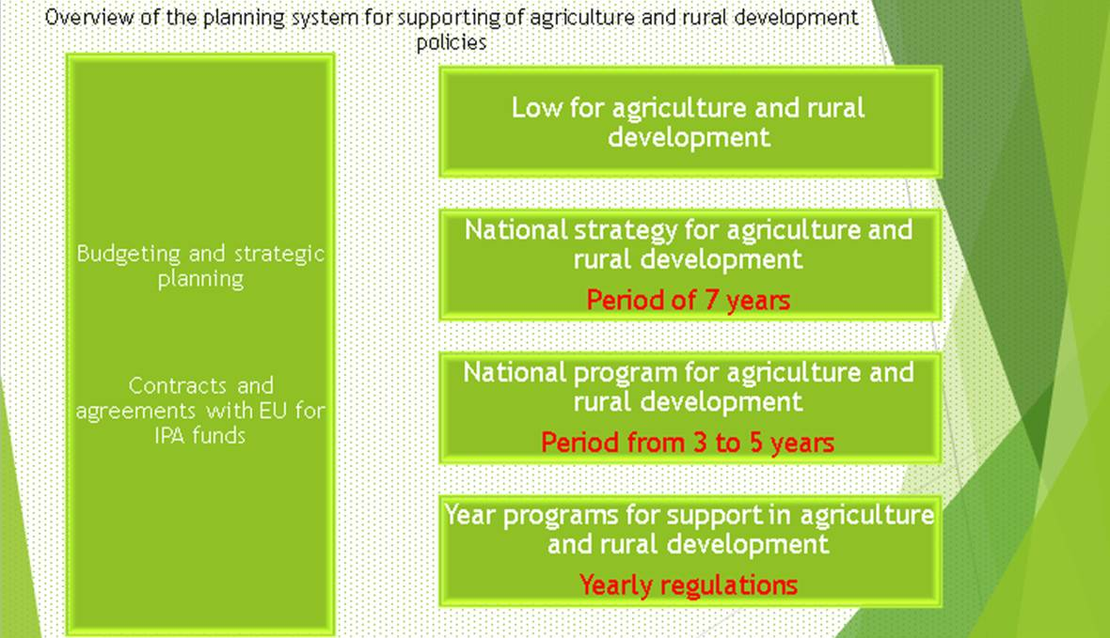

Suggestion: The action plan of the strategy of family agriculture economy has to be led according to the time frame of planning of the above stated documents, to be effective for the implementation of the measurements that will have impact for improvement of the quality of life of the family agriculture economy.

In the law for agriculture and rural development an Only register of agricultural economy has been defined

The Ministry leads unique register of agricultural economics (URAE). Basis for leading of URAE and its connection with other registers is the single identification number of the agricultural economy (in the text bellow as: IDNR). IDNR is determined with enrollment of the agricultural economy which with on one agricultural economy is assigned to one IDNR. The carrier of family agricultural economy and the members of the family agricultural economy are family related and they can be assigned to only one family agricultural economy in the register from the paragraph Carrier of family agricultural economy is a member of the family agricultural economy who is authorized from the other members of the family agricultural economy. Single legal person can be assigned as a carrier of one agricultural economy.

CATEGORIZATION OF THE FAMILY AGRICULTURAL ECONOMIES

In act 15 of the law for agriculture and rural development are categorized agricultural economies which have minimum 50 % of the total yearly net income by performing agricultural activity are categorized in four categories, such as:
-first category – family agricultural economies with realized yearly net income from performing of agricultural activity until the amount of the yearly net amount of minimal salary for the previous year, according with the data from the Ministry of labor and social politics,
- second category –family agricultural economies with realized yearly net income from performing of agricultural activity until the yearly net amount of the minimal salary for the previous year, according with the data from the Ministry of labor and social politics until yearly amount for minimal base for calculation and payment of contributions from compulsory social insurance,
- third category–family agricultural economies and agricultural economies with realized yearly net income from performing of agricultural activity from yearly amount of the minimum basis for calculation and payment of the contributes from the mandatory social insurance until realized yearly net income of performing agricultural activity up to 2.000.000 denars
- forth category – agricultural economies with realized yearly net income from performing of agricultural activity over 2.000.000 denars

According of the “Law for incomes from the mandatory social insurance” the carriers of the family agricultural economy which enter in the above- mentioned first, second and third category from the “Law of agriculture and rural development” are bonds to pay income for mandatory pension and disability insurance.
The biggest part of the families ,whose members are included in the everyday work on the agriculture economy and have landowner or farm, are registered as individual farmer economy or as minimal criteria for any registration which carries advantage for usage of financial funds from state programs for support.

National strategy for agriculture and rural development for period of 2014-2020
Adaptation of the national agricultural politics toward united agricultural politics in EU
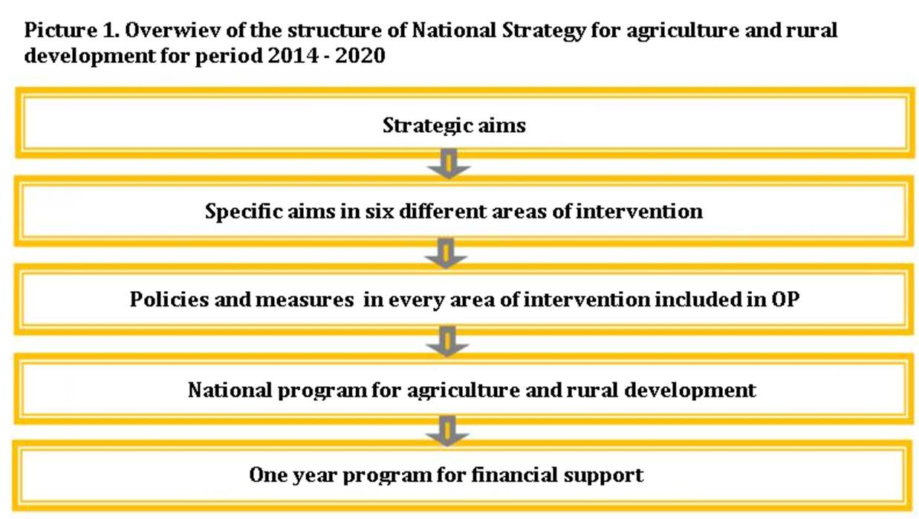
Due to the assumed obligation for adjustment of the national agricultural policies toward United agricultural policies in EU, the main provisions from the corps of the European policies in the agriculture and rural development are taken into consideration during the defining of the strategic steps elaborated in the sequel.
Adjustment of the politics, institutions and legislation in the agricultural- food sector toward LAP of EU, are representing the most demanding chapter of the negotiating process for EU membership because of the scope and complexity of the changes which are provided in the pre-accession process.
Subsector/ Categories | Fruit growing |  | Viticulture |  | Grains and animal food |  | Forage crops |  | Sheepherding |  | Goat breeding |  | Pig herding |  | Cattle breeding-  direction of milk / direction  meat
 | ha/herds | %of AHw.no | Ha/herds | % of AH w.no . | ha/herds | % of AH w.no | ha/herds | % of AH w.no | ha/herds | % of AH w.no | ha/herds | % of AH w.no . | ha/herds | % of AH w.no | ha/herds | % of AH w.no
Large agricultural holdings | Over 5 ha | 14% | Over 10 ha | 14% | Over 50 ha | 1% | Over 8 ha | 17% | Over 500 ha | 2,6% | Over 50 herds | 5,3% | 251-1.600  herds/51- 250herds | 0,6%/  2,1% | over20 herds | 3%
Agricultural holdings of first category | 3-5 ha | 14% | 3-10hа | 14% | 10-50  hа | 13%  над10 ха | 3-8hа | 30% | 300-500  herds | 5,3% | 21-50 herds | 6,6% | 11-50  herds | 10% | 11-20  herds /над 40herds јуниња | 4%
Agricultural holdings of first target category | 1-3 hа | 37% | 1-3hа | 37% | 5-10hа | 18% | 1-3hа | 36% | 100-300  herds | 30% | up to 6-20 | 26% | 6-10herds | 18,5% | 5-10herds /  30-40  herds | 21%
Small agricultural holdings | up to 1hа | 35% | Up to 1 ha | 35% | up to 5 ha | 68% | up to 1 ha | 16% | up to100 herds | 62% | up to5 herds | 65% | 1-5грла мајки | 68% | 4herds  /5 herds | 72%
For the reason that the small agricultural economies participate in the creating of significant part of the total agricultural production in the country with percent that is the least equivalent to their participation in the total number of holdings, as well as because of the significance of the incomes which these economies are insuring from performing of agricultural activity of their total incomes, the first two categories of agricultural economies as to size of engaged capacities which participation of the total number of economies is over 80%, are representing an aim of the politics of reconstruction in the next period.
... aims of the policies In the next period the reconstruction of the sector should be moving in direction of increasing of the number of the agricultural economies with larger engaged capacities, respectively increasing of the number of agricultural economies of the first target category and decreasing of participation of the smaller economies and agricultural economies of second target category in the total number of economies.

In the action plan of the National strategy for agriculture and rural development for period 2014-2020 activities are predicted for transition of the agricultural economies in higher developmental category.
Transitionof the agricultural economies in higher developmental category
The intensity for support of the co-financing of the costs from the investment project for category of small agricultural economies which want to transition in higher, second target category will equal 90%, while the economies which from second target category transition in economies of first target category will gain support for reconstruction with co-financing of 70% of the costs.
Because of the identification of the users of the active politics of reconstruction and transitioning of the small agricultural economies into higher developed category, a distribution of the agricultural economies with size of their engaged capacities is made, in every agricultural sub-sector in which they are accomplishing the dominant amount from their agricultural incomes.

As such the agricultural economies are categorized in four groups of:

    - Large agricultural economies;

    - Agricultural economies of first target category of the agricultural politics;

    - Agricultural economies of second target category of the agricultural politics; and

    - Small agricultural economies.

Arrangement of the legal status of the agricultural economies

The success and intensity of the process of the reconstruction of the sector and achieving of the set objectives, besides through active measurements of politics, especially depends also from enabling of appropriate favorable conditions for business operators who should support the process of the change of the existing structure.
In that direction, it is necessary to edit the legal status of the family agricultural economies that best fits on their current level of economic development and social condition.
The existing options for status regulation of the agricultural economies according to the Law of Existing trading corporations and the Law for performing of agricultural activity in the past period, result with insufficient interest from the agricultural economies.
Even 90%, of the total number of economies which are identified in ORAE are family agricultural economies without formal legal status, and only around 1.200 registered Individual agricultures.
In that direction, in the next period a reform will be implemented for regulating of the legal status of the family agricultural economies which they would fulfill specified prerequisites with regulation of the rights and duties of their members in relation to privileged mandatory social insurance.
This can be reached with rearrangement of the status of the Individual farmers through change of the “Law for performing of agricultural activity” and their preregistration in Family agricultural economies with legal status. This form would cover family economies with incomes of over 350.000 denars. Family agricultural economies with legal status as a category of holdings with significant or the biggest part of the incomes are being completed with performing of agricultural activity, because of they will be additionally supported with purpose of their stimulating o stay in this category. Simultaneously, with positioning of this form of economies, as the most attractive, the transition the family economies from the rest lower income categories without regulated legal status will be stimulated. In that direction, for this target category, insured additional financial support from 20% and beneficial social incomes in relation to corporations as their active member will be insured.

With re-registration and right distribution of the existing around 1.200 Individual farmers with appropriate category (Family agricultural economies with legal status or simple family agricultural economies), the long-term problem with non-payment of incomes and increasing of the debts from the side of the Individual farmers who realistically belong in lower category, will be solved. For regulation of the demands of contributions, especially for the interests, the possibility their settlement on a contractual basis and favorable conditions to be regulated by a separate law, will be reviewed.

The family agricultural economies which make income of over 1.000.000 denars, will have to have mandatory regulated legal status in one of these two forms: trade corporations, Family agricultural economies with legal status or cooperatives, as a condition for registering their production facilities in the ORAE.

Formulation of strategic aims

Specific strategic aims/ Key activities

- 1.COMMUNICATION/LOBBING/ NEGOTIATION
- Improvement of the processes of communication and negotiation in the frames of and between agricultural organizations, businesses, social groupings (syndicates), governmental institutions, professional science organizations, innovative bodies and research institutes, and family farmers for to build agricultural priorities;
- 2. NATIONAL PRIORITIES AND POLITICS
- Identification of the national priorities of functions and purposes of the small family farms, and creating of politics for to encourage these efforts (including, among the rest, the good governance and healthy economical politics, insurance for the rights of ownership, and suitable regulatory framework.
- 3. RESEARCH AND DEVELOPMENT
- Focus on the family farms in the agricultural research and development; long-term public obligations for agricultural research that support family farms are of essential importance, admitting that this kind of results of the research are important public deeds, irreplaceable from the side of private investments. Better relations between agricultural groupings and researchers can be provided in the focus of the priorities of the family farmers
- 4. HUMANITARIAN SERVICES
- Promoting of inclusive rural humanitarian services; the services in the agriculture are key for knowledge sharing for innovation and practices between family farmers
- 5. EDUCATION AND TRAINING
- Capacity building for innovations through education and training, with special focus on the women and the young through education, experience exchange
- 6. MARKETS AND MARKETING
Improving the access of markets for exports, imports and financial services for overcoming market’s failures, including creating conditions for fair trade between small farmers and agribusiness, and democratic control over the markets.

Implementation plan

 | Strategic purpose 1 | COMMUNICATION/LOBBING/NEGOTIATION
 |  | Year
Code | Activities /Measurements | 1 | 2 | 3 | 4 | 5 | Failure indicators | Evaluation | Budget МКД
S01-1 | Regular meetings with local associations of farmers, small organization of manufacturers, agricultural economies |  |  |  |  |  | Regular (half-yearly) information about the progress, number of the members, number of the membership, and equal activities | MB | 100.000
S01-2 | Participation of representatives of NCFF in commissions and bodies of MAFW and the rest organs within MAFW |  |  |  |  |  | Number of suggestions worked on, letters and views regarding the measures for promotion of agriculture and rural development | MB | 250.000
S01-3 | Regular meetings with the Payment agency for implementation of the measurements for purposes |  |  |  |  |  | Number of meetings held/ defined problems/ adapted suggestions | MB | 50.000
S01-4 | Regular meetings with the bodies for inspectional supervision in agricultural |  |  |  |  |  | Number of meetings held/ defined problems/ adapted suggestions | MB | 50.000
S01-5 | Meetings and workshops with the rest institutions within the Government of R.M. for questions from rural development and agriculture |  |  |  |  |  | Number of meetings held/ defined problems/ adapted suggestions | MB | 150.000
S01-6 | Analysis of the conditions in sub-sectors’ production groups |  |  |  |  |  | Prepared information for further using | MB | 240.000
S01-7 | Analysis of the family farms carriers of the economic development |  |  |  |  |  | Economic picture for the situations with family farms | MB | 260,000
S01-8 | Comparative advantages of the family farms |  |  |  |  |  | Prioritization of measurements for support of the family farms | MB | 310,000
S01-9 | Analysis of the possibilities for support of the ranking |  |  |  |  |  | Identification of the most appropriate markets and marketing | MB | 380,000

 | Strategic purpose 2 | NATIONAL PRIORITIES AND POLITICS
 |  | Year
Code | Activities /Measurements | 1 | 2 | 3 | 4 | 5 | Failure indicators | Evaluation | Budget МКД
S02-1 | Participation in the group for changing the legal and secondary legislation in the field of family farming |  |  |  |  |  | Number of meetings held/ Number of accepted suggestions submitted by the side of NCFF | MB | 100,000
S02-2 | Participation in the project for Agricultural Land Extension, FAO, Mainland |  |  |  |  |  | Number of submitted and adopted suggestions in the implementation process | MB | 50,000
S02-3 | Participation in the IPARD Committee for Monitoring the Implementation of the IPARD Program |  |  |  |  |  | Number of submitted and adopted suggestions in theimplementation process | MB | 50,000
S02-4 | Participation in the Organic Agriculture Committee at the MAFW |  |  |  |  |  | Number of submitted and adopted suggestions in the implementation process | MB | 50,000
S02-5 | Participation in the group for changing the legal and secondary legislation in the field of family farming |  |  |  |  |  | Number of meetings held/ Number of accepted suggestions submitted by the side of NCFF | MB | 150,000
S02-6 | Participation in the preparation of financial rulebooks and other administrative acts |  |  |  |  |  | Number of meetings held/ Number of accepted suggestions submitted by the side of NCFF | MB | 150,000
S02-7 | Participation in the creation and process of negotiating key economic policies |  |  |  |  |  | Number of meetings held/ Number of accepted suggestions submitted by the side of NCFF | MB | 150,000
S02-8 | Ensuring the right to agricultural land for all farmers |  |  |  |  |  | Number of submitted and adopted requirements to competent authorities | MB | 200,000

 | Strategic purpose 3 | RESEARCH AND DEVELOPEMENT
 |  | Year
Code | Activities /Measurements | 1 | 2 | 3 | 4 | 5 | Failure indicators | Evaluation | Budget МКД
S03-1 | Setting up demonstrative experiments for new varieties of fruit and vegetable crops |  |  |  |  |  | Improved yields and increased production | MB | 600,000
S03-2 | Analysis of new, more productive varieties of small and medium livestock |  |  |  |  |  | Improved yields and open market opportunities | MB | 400,000
S03-3 | Developed system for increased use of certified seedlings |  |  |  |  |  | Increased production quality | MB | 300,000
S03-4 | Training for grafting |  |  |  |  |  | Increased number of | MB | 300,000
S03-5 | Basic training on hygiene standards in animal livestock breeding |  |  |  |  |  | Enhanced milk quality | MB | 150,000
S03-6 | Trainings for rural areas for youth and women |  |  |  |  |  | Increased awareness of planting | MB | 250,000

 | Strategic purpose 4 | - RURAL DVELOPEMTN AND HUMANITARIAN SERVICES
 |  | Year
Code | Activities /Measurements | 1 | 2 | 3 | 4 | 5 | Failure indicators | Evaluation | Budget МКД
S04-1 | Analysis of the situation and development of the rural areas through 20-30 European parameters that determine the key developmental segments |  |  |  |  |  | Prepared material/ analytical priorities | MB | 250,000
S04-2 | Defining the crucial (structural) problems in the development of rural areas |  |  |  |  |  | List of problems and needs | MB | 200,000
S04-3 | Initiating the need for preparation of local action plans for rural development and agriculture in cooperation with ZELS |  |  |  |  |  | Increased conscious by municipalities and local environments | MB | 150,000
S04-4 | Preparation of 3 pilot plans for rural development and agriculture and support measures at the local and national level |  |  |  |  |  | Prepared 3 pilot plans | MB | 250,000
S04-5 | Improving the promotion of rural areas in the Republic of Macedonia through regular information and creating small informative media My Village, information board or virtual magazine on a weekly basis |  |  |  |  |  | Created and functional few media My Village in few environments | MB | 300,000
S04-6 | Monitoring matrix for monitoring of measures for support of rural development and their implications in rural areas |  |  |  |  |  | A functional matrix that provides regular data is created | MB | 240,000
S04-7 | Support in the process of ruralization, as well as appropriate economic and physical planning in the rural areas |  |  |  |  |  | Created regional plans for agricultural production | MB | 240,000
S04-8 | Virtual School for Beginners in Agriculture and Business, a project for rural areas |  |  |  |  |  | Established functional Internet tool as a space for sharing information and knowledg | MB | 220,000
S04-9 | Marking several important rural manifestations |  |  |  |  |  | Increased interest and familiarity with rural values and traditions | MB | 300,000

 | Strategic purpose 5 | EDUCATION AND TRAINING
 |  | Year
Code | Activities /Measurements | 1 | 2 | 3 | 4 | 5 | Failure indicators | Evaluation | Budget МКД
S05-1 | Organization of study trips |  |  |  |  |  | Number of members / number of visitors | MB | 600,000
S05-2 | Organization of trainings in rural areas for strengthening the organizational capacities for association |  |  |  |  |  | Number of local associations / producer organizations | MB | 300,000
S05-3 | Trainings for entrepreneurship in rural areas for young people and women |  |  |  |  |  | Increased awareness of local entrepreneurship | MB | 200,000
S05-4 | Handbook for business in rural areas |  |  |  |  |  | Increased number of businesses | MB | 250,000

 | Strategic purpose 6 | MARKETS AND MARKETING
 |  | Year
Code | Activities /Measurements | 1 | 2 | 3 | 4 | 5 | Failure indicators | Evaluation | Budget МКД
S06-1 | Organization of trade shows |  |  |  |  |  | Number of members/ number of visitors to trade shows | MB | 600,000
S06-2 | Analysis of local and regional markets for family producers |  |  |  |  |  | Number of new identified markets | MB | 200,000
S06-3 | Sales’manual and sales Channels |  |  |  |  |  | Increased number and type of customer | MB | 250,000
S06-4 | Organization of promotional and sales events in the region |  |  |  |  |  | Promotion of local environments / increased attendance and sales | MB | 300,000
S06-5 | Participation in national and international events |  |  |  |  |  | Increased interest in investing or selling local products | MB | 600,000
S06-6 | Enhanced access to financial products through information sessions |  |  |  |  |  | Improved liquidity of existing businesses | MB | 180,000
S06-7 | Adjustment of existing financial products to the needs of local businesses |  |  |  |  |  | Increased innovation and improved production technology | MB | 300,000

Sources of the financing

Potential sources of the financing are:
- Business sector (new investments)
- Creating of public- private partnerships in realization for united projects
- Philanthropists (people and entrepreneurships with will for help and high social responsibility
- IPARD fond
- Governmental programs for support and funds for development
- EU funds
- Sponsors
- Funds to promote sustainable development

